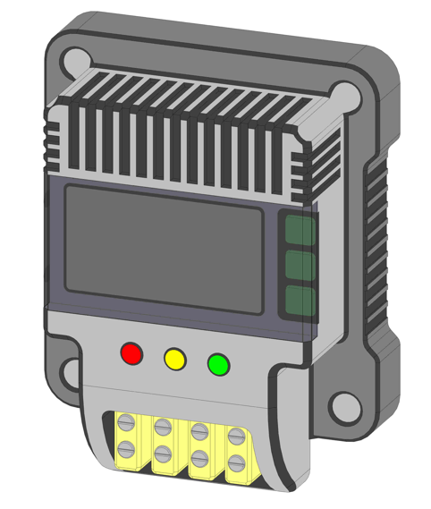
PERSPECTIVE VIEW

The novelty resides in the shape and configuration of the “⁠⁠⁠SMART ENERGY METER” as illustrated.
No claim is made by virtue of this registration in respect of any mechanical or other action of any mechanism whatever or in respect of any mode or principle of construction of the Article.
No claim is made by virtue of this registration to any right to the exclusive use of the words, color or color combination, logo/symbols, letters, numbers, or trade marks appearing in the representation.

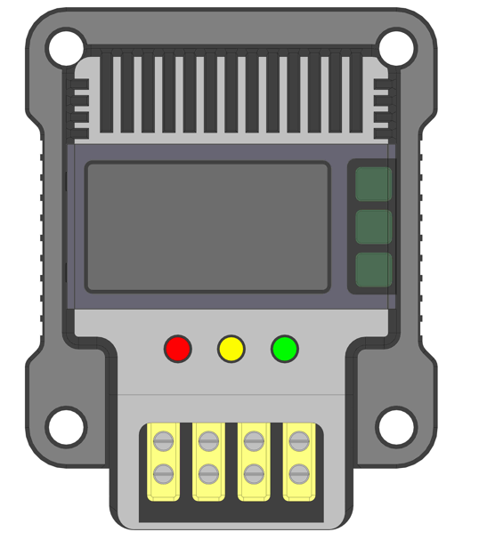
FRONT VIEW

The novelty resides in the shape and configuration of the “SMART ENERGY METER” as illustrated.
No claim i made by virtue of this registration in respect of any mechanical or other action of any mechanism whatever or in respect of any mode or principle of construction of the Article.
No claim is made by virtue of this registration to any right to the exclusive use of the words, color or color combination, logo/symbols, letters, numbers, or trade marks appearing in the representation.
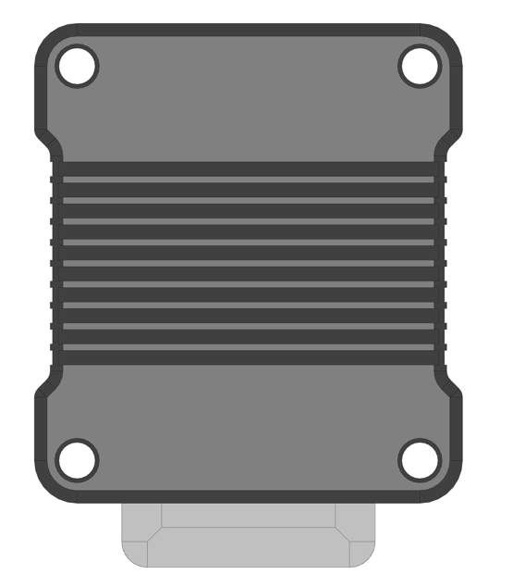
REAR VIEW

The novelty resides in the shape and configuration of the “SMART ENERGY METER” as illustrated.
No claim is made by virtue of this registration in respect of any mechanical or other action of any mechanism whatever or in respect of any mode or principle of construction of the Article.
No claim is made by virtue of this registration to any right to the exclusive use of the words, color or color combination, logo/symbols, letters, numbers, or trade marks appearing in the representation.

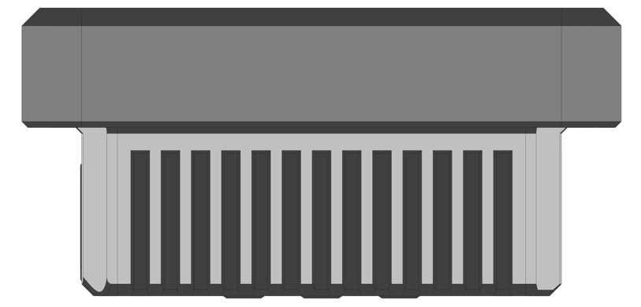
TOP VIEW

The novelty resides in the shape and configuration of the “SMART ENERGY METER” as illustrated.
No claim is made by virtue of this registration in respect of any mechanical or other action of any mechanism whatever or in respect of any mode or principle of construction of the Article.
No claim is made by virtue of this registration to any right to the exclusive use of the words, color or color combination, logo/symbols, letters, numbers, or trade marks appearing in the representation.

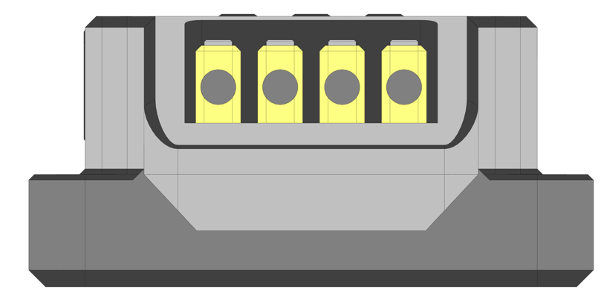
BOTTOM VIEW

The novelty resides in the shape and configuration of the “⁠⁠SMART ENERGY METER” as illustrated.
No claim is made by virtue of this registration in respect of any mechanical or other action of any mechanism whatever or in respect of any mode or principle of construction of the Article.
No claim is made by virtue of this registration to any right to the exclusive use of the words, color or color combination, logo/symbols, letters, numbers, or trade marks appearing in the representation.

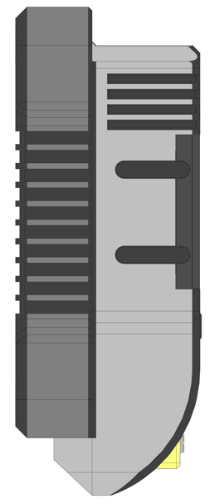
LEFT SIDE VIEW

The novelty resides in the shape and configuration of the “SMART ENERGY METER” as illustrated.
No claim is made by virtue of this registration in respect of any mechanical or other action of any mechanism whatever or in respect of any mode or principle of construction of the Article.
No claim is made by virtue of this registration to any right to the exclusive use of the words, color or color combination, logo/symbols, letters, numbers, or trade marks appearing in the representation
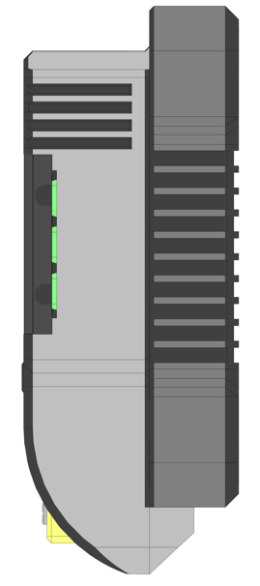
RIGHT SIDE VIEW

The novelty resides in the shape and configuration of the “SMART ENERGY METER” as illustrated.
No claim is made by virtue of this registration in respect of any mechanical or other action of any mechanism whatever or in respect of any mode or principle of construction of the Article.
No claim is made by virtue of this registration to any right to the exclusive use of the words, color or color combination, logo/symbols, letters, numbers, or trademarks appearing in the representation.

